CREATE DATABASE college;
CREATE TABLE student(
VTU_No VARCHAR(20) Primary Key,
Name VARCHAR(50) NOT NULL,
Email VARCHAR(20) UNIQUE,
Phone VARCHAR(10),
Dept VARCHAR(10));
CREATE TABLE Course (
Course_Code VARCHAR(20) PRIMARY KEY,
Course_Name VARCHAR(100) NOT NULL,
Faculty_Id VARCHAR(20),
Student_ID VARCHAR(20),
Faculty_Email VARCHAR(100),
FOREIGN KEY (Student_ID) REFERENCES Student(VTU_No));
CREATE TABLE Faculty (
faculty_id VARCHAR(10) PRIMARY KEY,
faculty_name VARCHAR(100) NOT NULL,
department VARCHAR(50),
designation VARCHAR(50)
);
CREATE TABLE Enrollments (
enrollment_id INT AUTO_INCREMENT PRIMARY KEY,
vtu_no VARCHAR(20),
course_id VARCHAR(20), -- This name is fine here...
faculty_id VARCHAR(10),
grade VARCHAR(2),
semester INT,
FOREIGN KEY (vtu_no) REFERENCES Student(vtu_no),
-- ...BUT it must point to 'Course_Code' here:
FOREIGN KEY (course_id) REFERENCES Course(Course_Code),
FOREIGN KEY (faculty_id) REFERENCES Faculty(faculty_id)
);
INSERT INTO Enrollments (vtu_no, course_id, faculty_id, grade, semester) VALUES
('1CR21CS001', 'CS101', 'FAC001', 'A+', 4),
('1CR21CS002', 'CS102', 'FAC002', 'S', 6),
('1CR21CS005', 'CS103', 'FAC003', 'A', 8),
('1CR21EC003', 'EC201', 'FAC004', 'B', 2),
('1CR21ME004', 'ME301', 'FAC005', 'C', 4);

INSERT INTO Faculty (faculty_id, faculty_name, department, designation) VALUES
('FAC001', 'Dr. Aruna Devi', 'Computer Science', 'Professor'),
('FAC002', 'Mr. Rajesh Kumar', 'Computer Science', 'Asst. Professor'),
('FAC003', 'Dr. Sarah Johnson', 'ISE', 'Associate Professor'),
('FAC004', 'Prof. Amit Sharma', 'Mechanical', 'Head of Dept'),
('FAC005', 'Ms. Priya Menon', 'ECE', 'Asst. Professor'),
('FAC006', 'Dr. Vikram Rathore', 'Civil', 'Professor'),
('FAC007', 'Dr. Sneha Paul', 'Electronics', 'Associate Professor');
INSERT INTO Course VALUES
('CS101', 'Data Structures', 'FAC001', '1CR21CS001', 'faculty1@college.edu'),
('CS102', 'Database Systems', 'FAC002', '1CR21CS002', 'faculty2@college.edu'),
('EC201', 'Digital Electronics', 'FAC003', '1CR21EC003', 'faculty3@college.edu'),
('ME301', 'Thermodynamics', 'FAC004', '1CR21ME004', 'faculty4@college.edu'),
('CS103', 'Operating Systems', 'FAC001', '1CR21CS005', 'faculty1@college.edu');
INSERT INTO student VALUES
('1CR21CS001','sai','sai@gmail.coom','0123456789','CSE'),
('1CR21CS002', 'Priya Patel', 'patel@college.edu', '9876543211', 'CSE'),
('1CR21EC003', 'Amit Kumar', 'kumar@college.edu', '9876543212', 'ECE'),
('1CR21ME004', 'Sneha Reddy', 'sneha@college.edu', '9876543213', 'Mech'),
('1CR21CS005', 'Vikram Singh', 'vikram@college.edu', '9876543214', 'CSE');
- SELECT*from student
Output: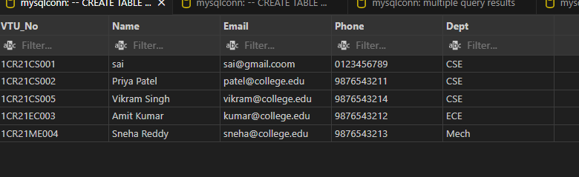
- SELECT*from course
Output:
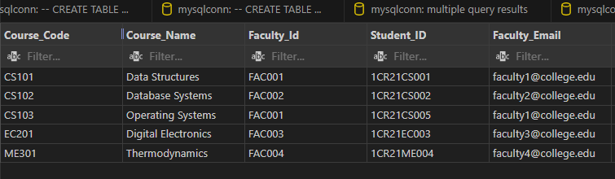
- SELECT*FROM Faculty
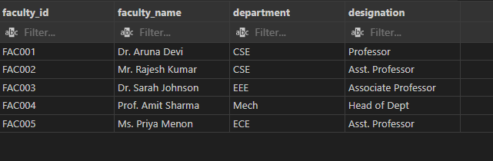
- SELECT*FROM Enrollments
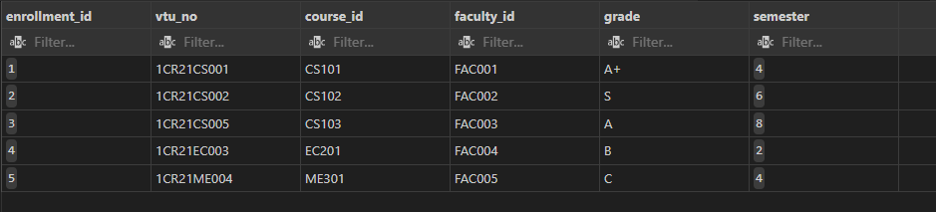
- SELECT with WHERE Clause:
SELECT * FROM Student
WHERE Dept = 'CSE';

- ORDER BY Clause - Sort by name
SELECT * FROM Student ORDER BY Name ASC;

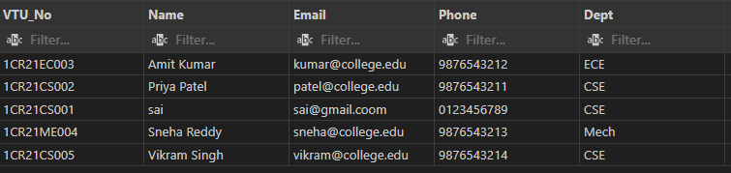

- LIKE Clause - Names starting with 'S' (Updated to match your data)
SELECT * FROM student
WHERE Name LIKE 'S%';



- IN Clause - Multiple departments (Matches your 'CSE', 'ECE' abbreviations)
SELECT * FROM student
WHERE Dept IN ('CSE', 'ECE');

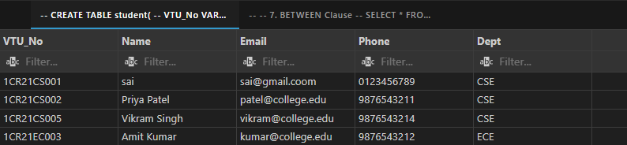

- BETWEEN Clause
SELECT * FROM student
WHERE VTU_No BETWEEN '1CR21CS001' AND '1CR21CS003';


- AND Clause
SELECT * FROM student
WHERE Dept = 'CSE' AND VTU_No LIKE '%001';



- OR Clause
SELECT * FROM student
WHERE Dept = 'CSE' OR Dept = 'Mech';



- DISTINCT Clause
SELECT DISTINCT Dept FROM student;



- COUNT and GROUP BY
SELECT Dept, COUNT(*) as Total_Students
FROM student
GROUP BY Dept;

- HAVING Clause
SELECT Dept, COUNT(*) as Total_Students
FROM student
GROUP BY Dept
HAVING COUNT(*) > 1;



- JOIN Clause
SELECT s.Name, s.Dept, c.Course_Name, c.Faculty_Email
FROM student s
INNER JOIN Course c ON s.VTU_No = c.Student_ID;

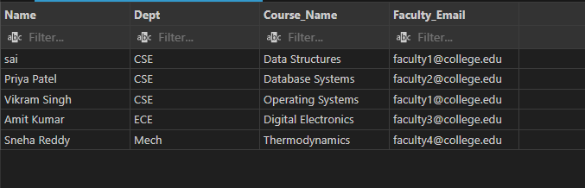

- LIMIT Clause
SELECT * FROM student
LIMIT 3;



- Specific columns only
SELECT Name, Email, Dept FROM student;


- WHERE with multiple conditions
SELECT * FROM student
WHERE Dept = 'CSE' AND Phone IS NOT NULL;



- ORDER BY DESC
SELECT * FROM Course
ORDER BY Course_Name DESC;

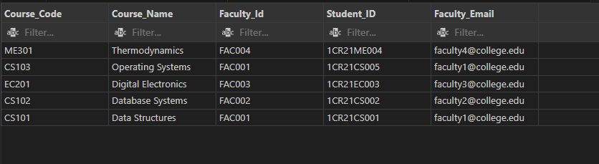

Aggregate Queries

- Count students by department:
SELECT dept, AVG(cgpa) AS avg_cgpa
FROM student
GROUP BY dept
HAVING AVG(cgpa) > 8.0;


- Average CGPA by department:
SELECT
dept,
ROUND(AVG(cgpa), 2) AS avg_cgpa,
MIN(cgpa) AS min_cgpa,
MAX(cgpa) AS max_cgpa,
COUNT(*) AS students_count
FROM student
GROUP BY dept;


ALTER TABLE Course
ADD COLUMN credits INT DEFAULT 0;
UPDATE Course
SET credits = CASE
WHEN Course_Code = 'CS101' THEN 4
WHEN Course_Code = 'CS102' THEN 4
WHEN Course_Code = 'EC201' THEN 3
WHEN Course_Code = 'ME301' THEN 4
WHEN Course_Code = 'CS103' THEN 3
END
WHERE Course_Code IN ('CS101', 'CS102', 'EC201', 'ME301', 'CS103');
- Total credits:
SELECT
s.Dept,
SUM(c.credits) AS total_credits
FROM Course c
JOIN student s ON c.Student_ID = s.VTU_No
GROUP BY s.Dept;

ALTER TABLE student
ADD COLUMN semester INT DEFAULT 1;
UPDATE student
SET semester = CASE
WHEN VTU_No = '1CR21CS001' THEN 5
WHEN VTU_No = '1CR21CS002' THEN 7
WHEN VTU_No = '1CR21CS005' THEN 1
WHEN VTU_No = '1CR21EC003' THEN 3
WHEN VTU_No = '1CR21ME004' THEN 5
END
WHERE VTU_No IN ('1CR21CS001', '1CR21CS002', '1CR21CS005', '1XX21EC003', '1XX21ME004');

- SELECT
s.VTU_No,
s.Name AS student_name,
c.Course_Name,
f.faculty_name,
e.grade
FROM student s
INNER JOIN Enrollments e ON s.VTU_No = e.vtu_no
INNER JOIN Course c ON e.course_id = c.Course_Code
INNER JOIN Faculty f ON e.faculty_id = f.faculty_id
WHERE s.VTU_No = '1CR21CS001';



- Select set of students based on course and count the number of students
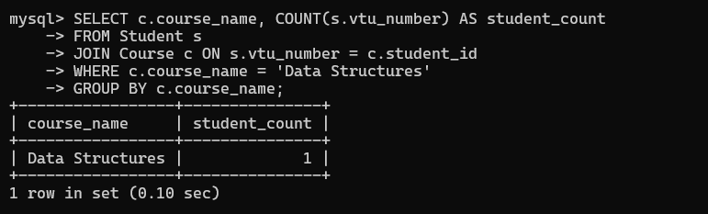

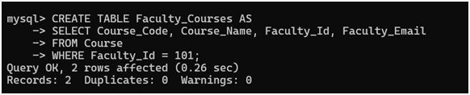
- 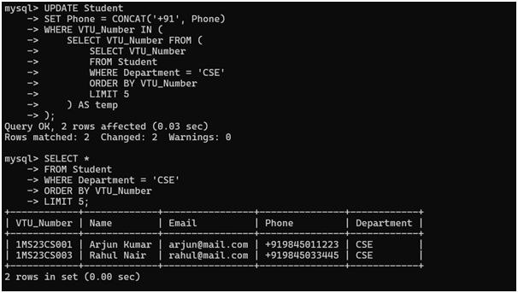
- 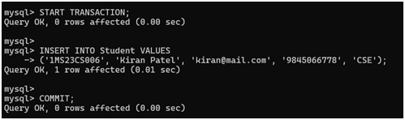
- 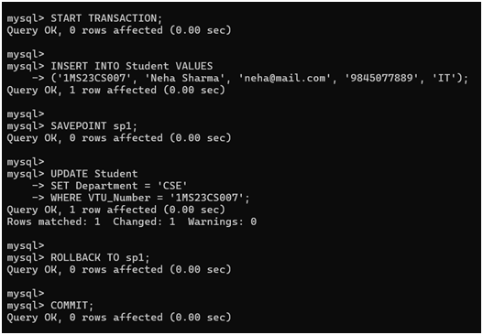
- 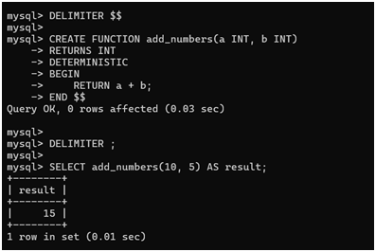
30. 

